Daily News
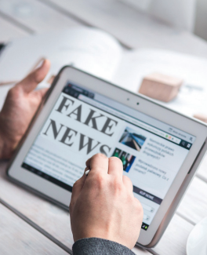
Can You Spot the Fake from the Real?
• Fake news is news which is fake, not true or made up. It works by shocking people into reading it.
• Fake news is often designed to get people’s attention and get as many readers as possible.
How good are you at spotting real news from
fake? We’ve got three news stories here but not
all of them are real!

Woman Eating Dog Biscuits
An 82-year-old woman from somewhere in England, has been mistakenly snacking on dog biscuits for over 11 years, according to my friends.
“She thought the bone shape was just a fun design!” said a neighbor.
The jokes are not just on her, though. “Her snacks have done particularly well at the local school bake sale,” someone revealed!
Sweet Potatoes Help You Drive
A video making fun of fake news went viral last month. But, it appears some people may have mistaken it for real news as sales of sweet potatoes soar.
The video claimed that putting lots and lots of sweet potato peelings in your socks can make you a better driver.
Although clearly a joke, supermarkets have reported a huge increase in sweet potato sales. The filmmakers are now worried that their video has now actually become fake news … and that
Some people now have very smelly socks!

Pull Over Rover
In March 2020, a 51-year-old man from Washington state, USA, led police on a high-speed chase. It was because he was teaching his dog to drive. The car hit two other vehicles and got up to speeds of 109mph all while the man’s favorite pooch sat on his lap.
When the vehicle was eventually stopped, the driver told state troopers he had been trying to teach his pit bull to drive.
“When we took him into custody... he admitted to our troopers that he was trying to teach his dog to drive,” State Trooper Heather Axtman told US media.
The man went to jail, the dog… to an animal shelter.
Fake or Real?
So what do you think? Which stories are real and which are fake? Use the information on the sheet to help you work out which stories you can trust and which might just be fake news!
After that, why not write your own fake news story? Remember, fake news wants to get lots of people to read and share it.
Can you make a shocking fake news story that is nearly believable?

Questions

- Which story or stories you think are fake.

- Why do you think that?

Fake News...What do You Know?
1. Name three news producers you could trust.

2. Name two reasons that people create fake news?

3. Name three things that would make you suspicious about news being fake.

4. Name two or more ways that you can check if a story is real or not.

5. Name two ways that gossip is similar to fake news.

6. How is satire different from fake news?

7. What is propaganda?

8. Can you believe the photos? Why?

